The main idea of function is the same as C++

* Functions
  + Let us wrap bits of code up into reusable packages. They are one of the building block of JS
  + Syntax:
    - function doSomething( ) {  
       console.log(“Hello World”);  
      }
    - doSomething(); //This will be calling the function
  + Note
    - clear()
      * This is a built in function in JavaScript
* Arguments
  + When a function takes a input
  + Syntax:
    - function doSomething(num) {  
       console.log(num \* num);  
      }
    - square(10) //Prints 100
  + Example:
    - Function Greet(person1, person2, person3){  
       console.log(“hi “ + person1);  
       console.log(“hi “ + person2);  
       console.log(“hi “ + person3);  
      }
    - Greet(“Harry”, “Ron”, “Hermini”);
      * This will return every individual with a hi
    - Greet(“Harry”, “Ron”,);
      * This will return “hi person” except the class one
* The Return Keyword
  + The big difference between the “return” and “console.log” is that
    - Return
      * It is capturing the value that is coming out of the function
    - Console.log
      * Just prints out the value
  + Example
    - function square(x) {  
       console.log(x \* x);  
      }
      * This will print out the result but not return the value
    - “4 squared is: “ + square(4);  
      //Result: 4 squared is undefined
    - function square(x) { //This is the solution  
       return(x \* x);  
      }
    - “4 squared is: “ + square(4);  
      //Result: 4 squared is 16
    - Note
      * If we look at the arrow it will be different
  + We can also save it in a variable
    - Example
      * var result = square(104);  
        result;
  + Example  
    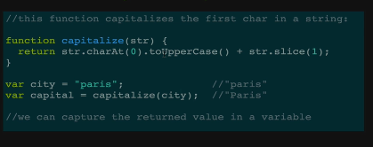  
      
      
    - Str.charAt(0).toUpperCase()
      * This would take the first character of the string and make it uppercase
    - str.slice(1)
      * Takes in a number (1) and starts from that index and traverse throughout the string
  + Example  
    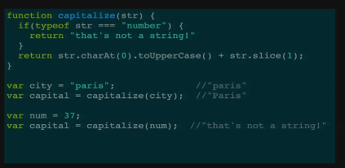  
    - If(typeof str === “number”)
      * This is checking if our string is a number value
    - In this function, we would input anything and check if that value is a string, if it is we will return it with the uppercase
  + Function Declaration vs Function Expression  
    